FML LAB RECORD

NAME : V.GANAVI
REG NO : 11259A514
SECTION : S9
SUBJECT : FUMDAMENTALS OF MECHINE LEARNING

EXERCISE-1

1.import numpy.version as np
print(np. version )
2.import numpy as np
x=np.arange(2,6).reshape(4)
print(x)
3.import numpy as np
x=np.arange(2,10).reshape(2,4)
print(x)
4.import numpy as np
x=np.arange(24).reshape(4,3,2)
print(x)
5.import numpy as np
arr=np.array([1,2,3,4])
print(arr[1:3:2])
print(arr[:3])
print(arr[::2])
6.import numpy as np
arr=np.array([0,30,60,90])
print(np.sin(arr))
print(np.cos(arr))
print(np.tan(arr))
7.import numpy as np
l = [12.23, 13.32, 100, 36.32]
print("Original List:", l)
a = np.array(l)
print("One-dimensional NumPy array: ", a)
8.import numpy as np
x = np.arange(12, 38)
print(x)
9.import numpy as np
import numpy as np
x = np.arange(12, 38)
print("Original array:")
print(x)
print("Reverse array:")
x = x[::-1]
print(x)
10.import numpy as np
x = [10, 20, 30]
print("Original array:")
print(x)
x = np.append(x, [[40, 50, 60], [70, 80, 90]])
print("After append values to the end of the array:")
print(x)
11.import numpy as np
array1 = np.array([0, 10, 20, 40, 60])
print("Array1: ",array1)
array2 = [10, 30, 40]
print("Array2: ",array2)
print("Common values between two arrays:")
print(np.intersect1d(array1, array2))
12.import numpy as np
array1 = np.array([0, 10, 20, 40, 60, 80])
print("Array1: ",array1)
array2 = [10, 30, 40, 50, 70]
print("Array2: ",array2)
print("Unique sorted array of values that are in either of the two input arrays:")
print(np.union1d(array1, array2))
13.import numpy as np
a = np.array([[0, 1, 3], [5, 7, 9]])
b = np.array([[0, 2, 4], [6, 8, 10]])
c = np.concatenate((a, b), 1)
print(c)
14.import numpy as np
fvalues = [0, 12, 45.21, 34, 99.91, 32]
F = np.array(fvalues)
print("Values in Fahrenheit degrees:")
print(F)
print("Values in Centigrade degrees:")
print(np.round((5*F/9 - 5*32/9),2))
15.import numpy as np
a = np.arange(9, dtype=np.float64).reshape(3, 3)
print("First Array:")
print(a)
b = np.array([10, 20, 30])
print("Second Array:")
print(b)
print("Addition of Arrays:")
print(np.add(a, b))
print("Subtraction of Arrays:")
print(np.subtract(a, b))
print("Multiplication of Arrays:")
print(np.multiply(a, b))
print("Division of Arrays:")
print(np.divide(a, b))
Outputs
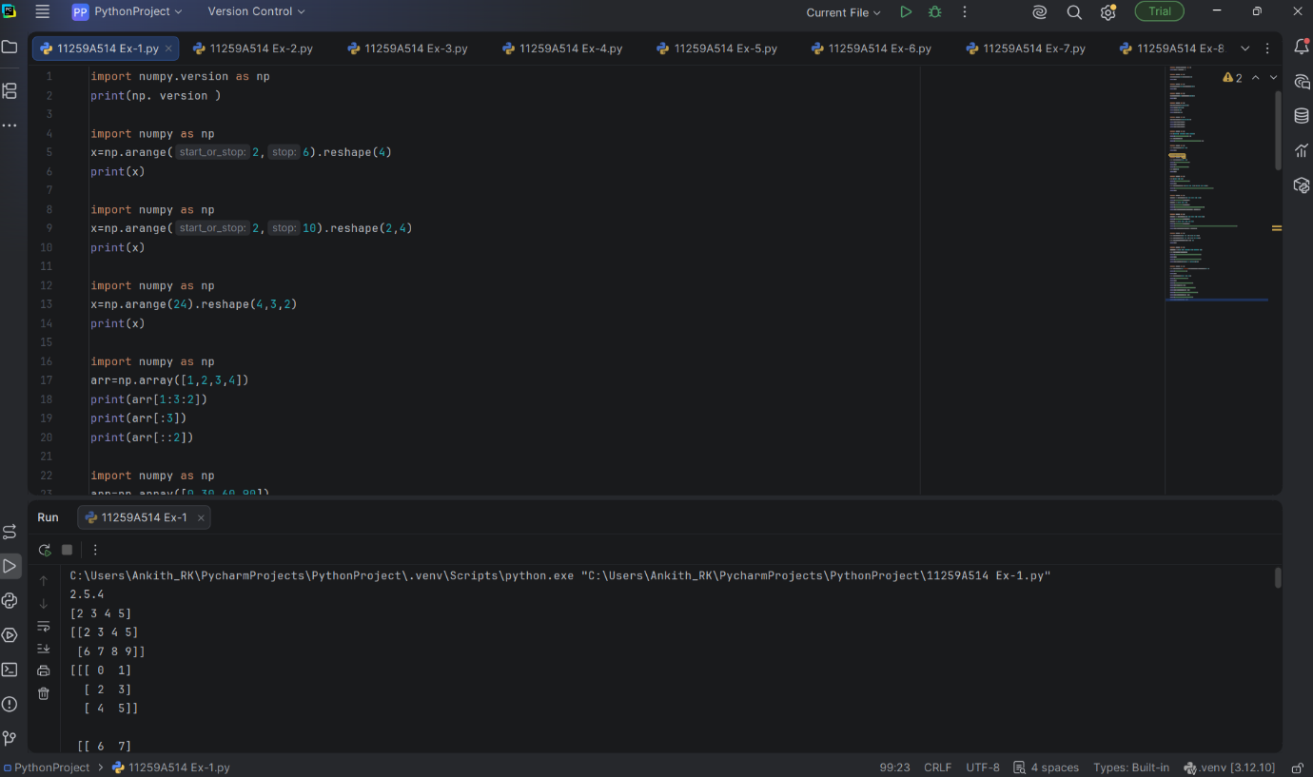

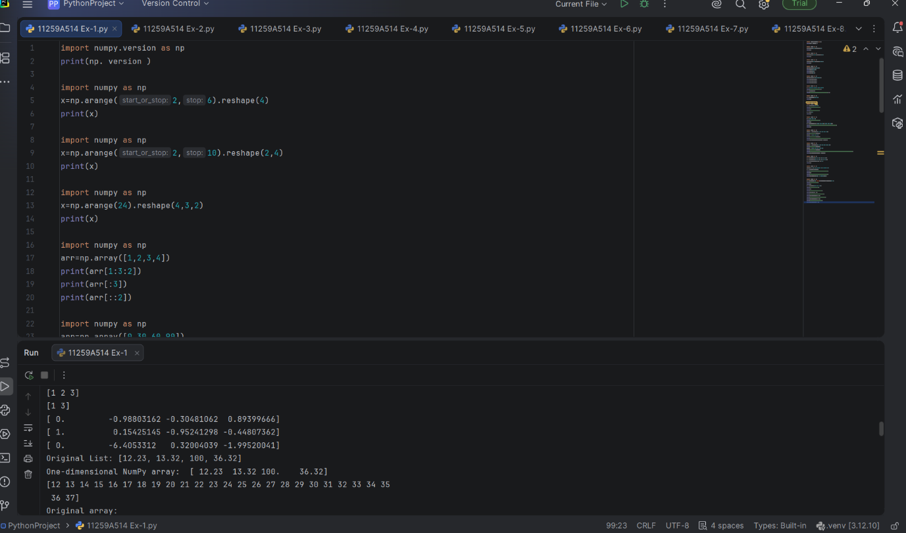

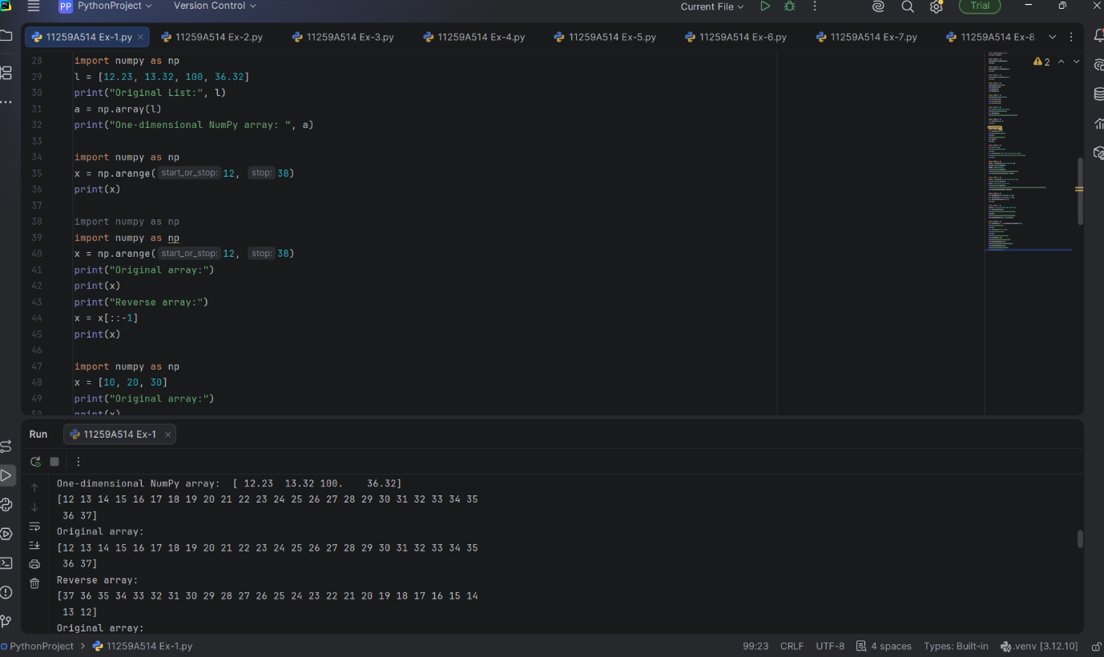

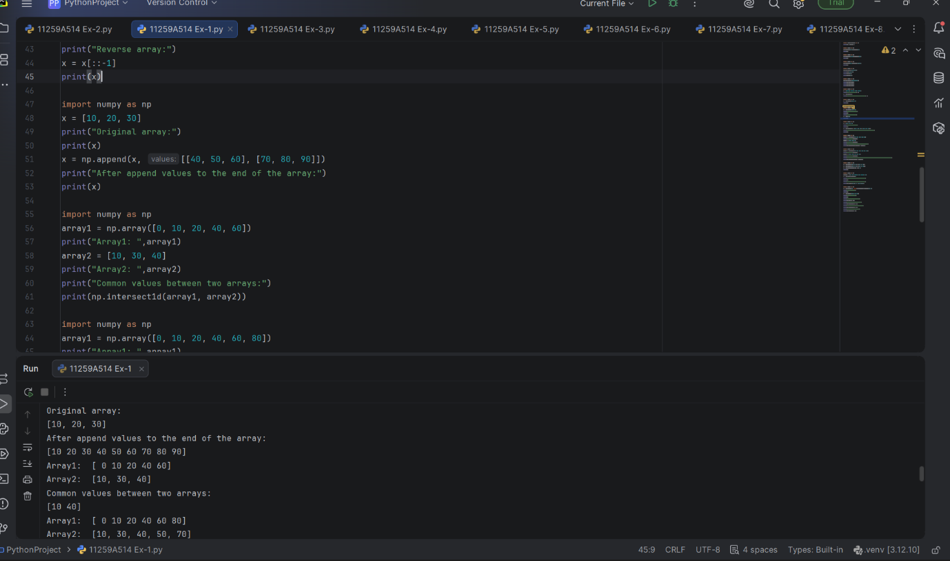

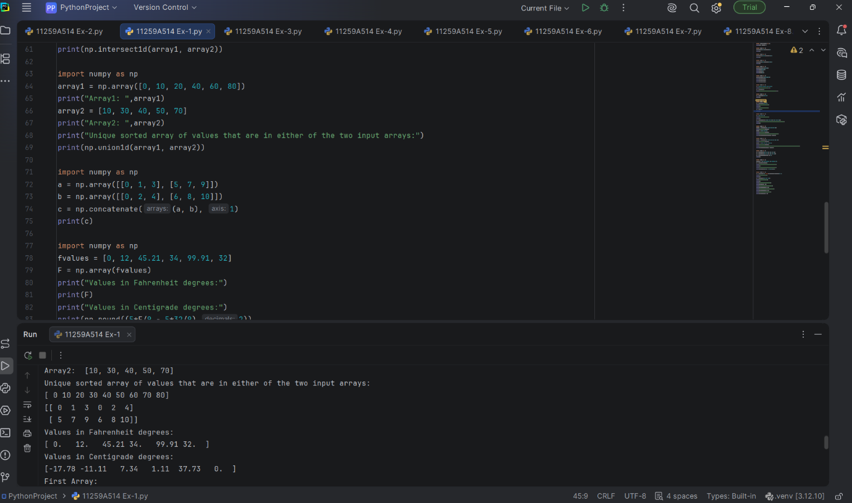

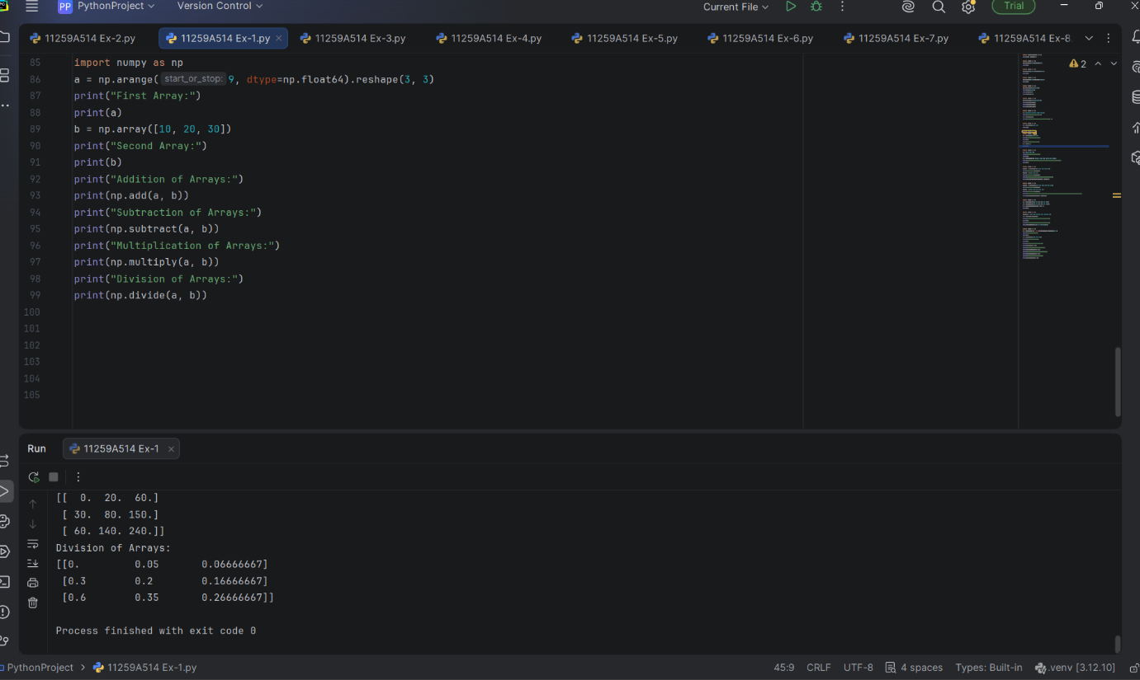

EXERCISE-2
1.import pandas as pd
import numpy as np
exam_data = {'name': ['Anastasia', 'Dima', 'Katherine', 'James', 'Emily', 'Michael', 'Matthew', 'Laura', 'Kevin', 'Jonas'],
'score': [12.5, 9, 16.5, np.nan, 9, 20, 14.5, np.nan, 8, 19],
'attempts': [1, 3, 2, 3, 2, 3, 1, 1, 2, 1],
'qualify': ['yes', 'no', 'yes', 'no', 'no', 'yes', 'yes', 'no', 'no', 'yes']}
labels = ['a', 'b', 'c', 'd', 'e', 'f', 'g', 'h', 'i', 'j']
df = pd.DataFrame(exam_data , index=labels)
print(df)
2.df = pd.DataFrame(exam_data , index=labels)
print("Summary of the basic information about this DataFrame and its data:")
print(df.info())
3.df = pd.DataFrame(exam_data , index=labels)
print("First three rows of the data frame:")
print(df.iloc[:3])
4.df = pd.DataFrame(exam_data , index=labels)
print("Select specific columns:")
print(df[['name', 'score']])
5.df = pd.DataFrame(exam_data, index=labels)
print("Number of attempts in the examination is greater than 2:")
print(df[df['attempts'] > 2])
6.df = pd.DataFrame(exam_data , index=labels)
total_rows=len(df.axes[0])
total_cols=len(df.axes[1])
print("Number of Rows: "+str(total_rows))
print("Number of Columns: "+str(total_cols))
7.df = pd.DataFrame(exam_data , index=labels)
print("Rows where score is missing:")
print(df[df['score'].isnull()])
8.df = pd.DataFrame(exam_data , index=labels)
print("Original rows:")
print(df)
print("\nAppend a new row:")
df.loc['k'] = ['Suresh',15.5, 1, 'yes']
print("Print all records after insert a new record:")
print(df)
print("\nDelete the new row and display the original rows:")
df = df.drop('k')
print(df)
9.df = pd.DataFrame(exam_data , index=labels)
print("Orginal rows:")
print(df)
df.sort_values(by=['name', 'score'], ascending=[False, True])
print("Sort the data frame first by ‘name’ in descending order, then by ‘score’ in ascending order:")
print(df)
10.df = pd.DataFrame(exam_data , index=labels)
print("Original rows:")
print(df)
print("\nChange the name 'James' to ‘Shyam’:")
df['name'] = df['name'].replace('James', 'Shyam')
print(df)

OUTPUTS
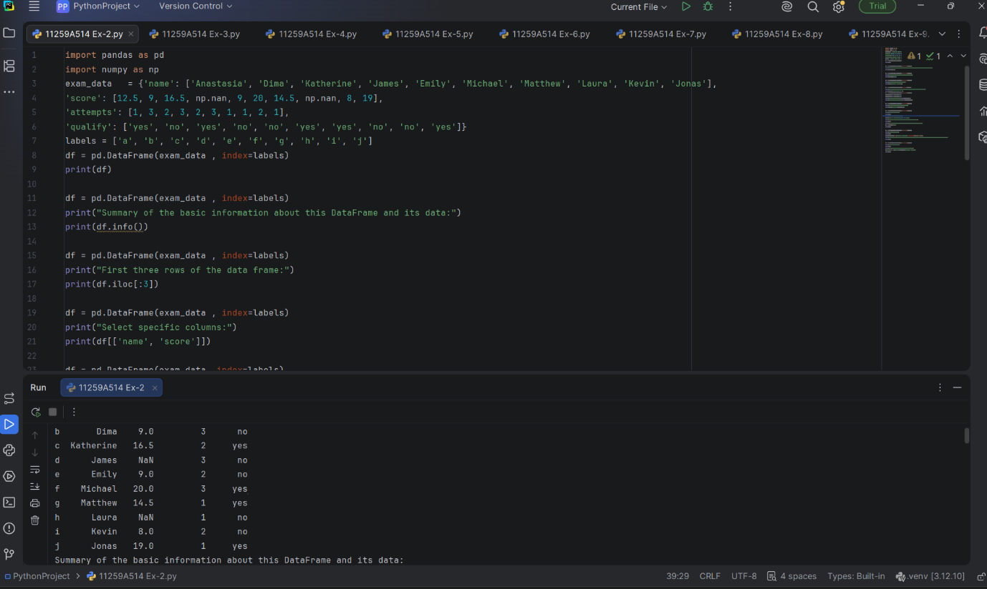

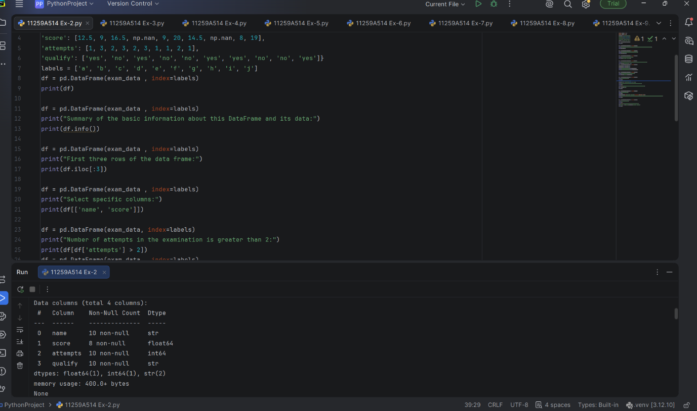

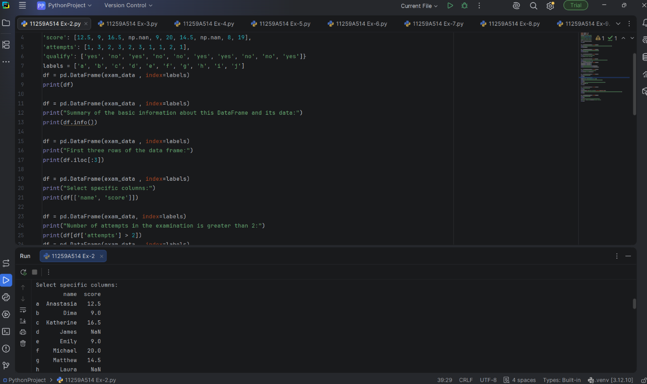

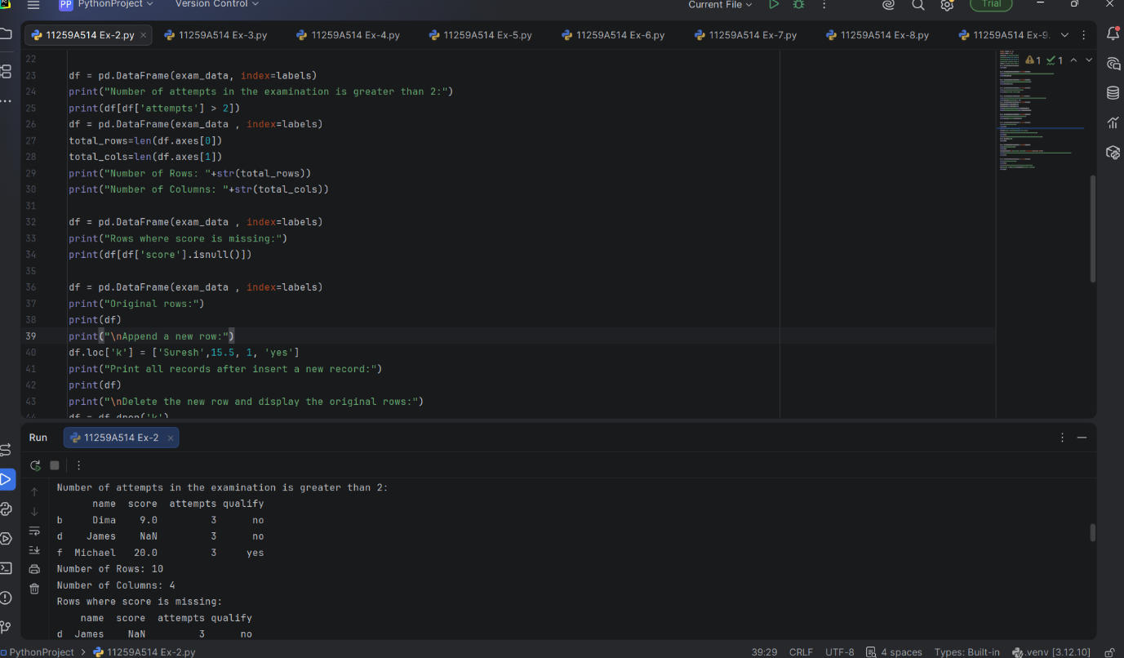

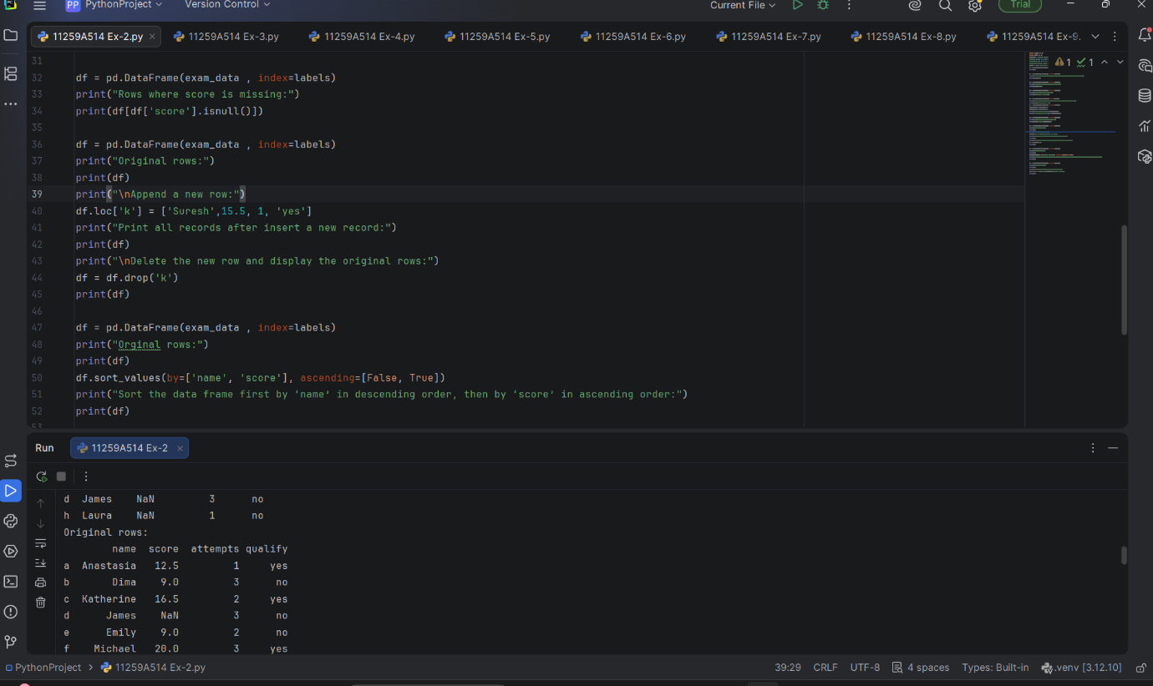

EXERCISE-3
1.marks = [78, 85, 92, 67, 88, 90, 76]
print("Highest Mark:", max(marks))
print("Lowest Mark:", min(marks))
print("Average Mark:", sum(marks)/len(marks))
2.temperature = [25, 30, 28, 35, 32]
print("Maximum Temperature:", max(temperature))
print("Minimum Temperature:", min(temperature))
print("Average Temperature:", sum(temperature) / len(temperature))
3.sales = [2500, 3000, 2800, 3500, 4000, 3800, 4200]
print("Total Sales:", sum(sales))
print("Average Sales:", sum(sales)/len(sales))
4.ids = [101, 102, 103, 104, 105, 106]
even = []
odd = []
for i in ids:
if i % 2 == 0:
even.append(i)
else:
odd.append(i)
print("Even IDs:", even)
print("Odd IDs:", odd)
5.values = [20, -5, 15, -10, 30, -2]
positive = 0
negative = 0
for i in values:
if i > 0:
positive += 1
elif i < 0:
negative += 1
print("Positive Values:", positive)
print("Negative Values:", negative)
6.customer_ids = [101, 102, 103, 102, 104, 105, 101]
duplicates = []
for i in customer_ids:
if customer_ids.count(i) > 1 and i not in duplicates:
duplicates.append(i)
print("Duplicate IDs:", duplicates)
prices = [250, 450, 120, 600, 350]
print("Highest Price:", max(prices))
print("Lowest Price:", min(prices))
salary = [25000, 30000, 40000, 35000]
new_salary = []
for s in salary:
new_salary.append(s * 1.10)
print("Updated Salaries:", new_salary)
7.total_classes = 90
attended = 81
percentage = (attended / total_classes) * 100
print("Attendance Percentage:", percentage)
marks = [45, 67, 89, 32, 78, 55, 49]
passed = []
for m in marks:
if m >= 50:
passed.append(m)
print("Passed Students Marks:", passed)
8.prices = [120, 80, 150, 200]
total = sum(prices)
print("Total Bill:", total)
feedback = "good service good quality excellent service"
words = feedback.split()
for word in set(words):
print(word, ":", words.count(word))
9.ages = [12, 25, 45, 67, 15]
for age in ages:
if age < 18:
print(age, "Child")
elif age < 60:
print(age, "Adult")
else:
print(age, "Senior Citizen")
units = 250
if units <= 100:
bill = units * 2
elif units <= 200:
bill = 100 * 2 + (units - 100) * 3
else:
bill = 100 * 2 + 100 * 3 + (units - 200) * 5
print("Electricity Bill:", bill)
10.expenses = [12000, 15000, 18000, 11000, 17000]
highest = max(expenses)
month = expenses.index(highest) + 1
print("Highest Expense:", highest)
print("Month:", month)
OUTPUTS
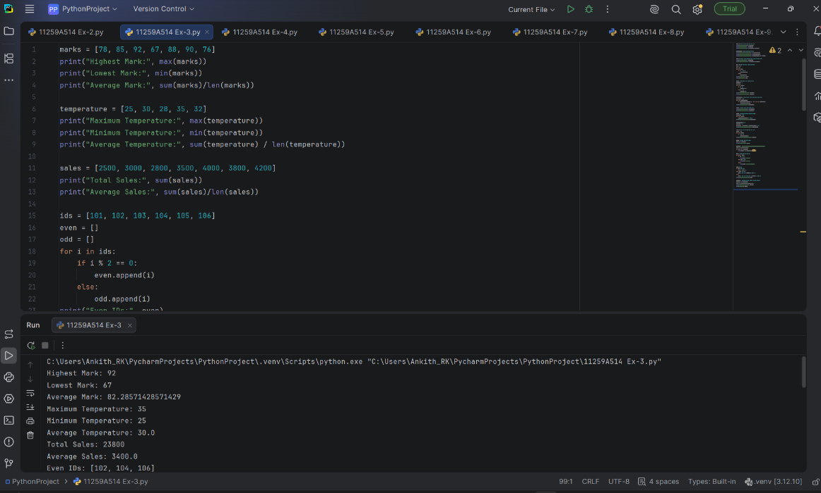
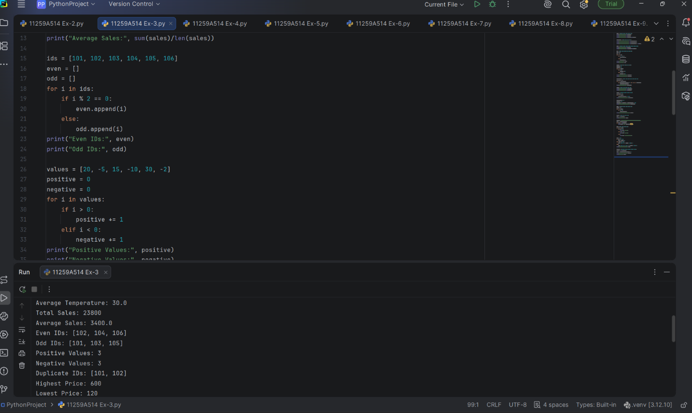

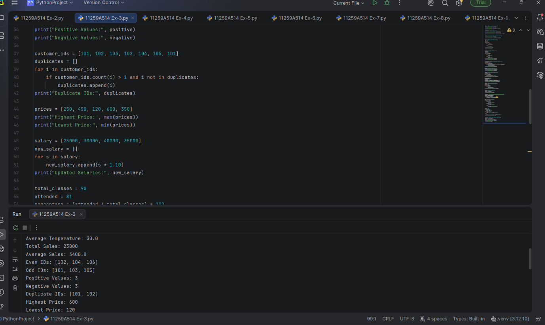

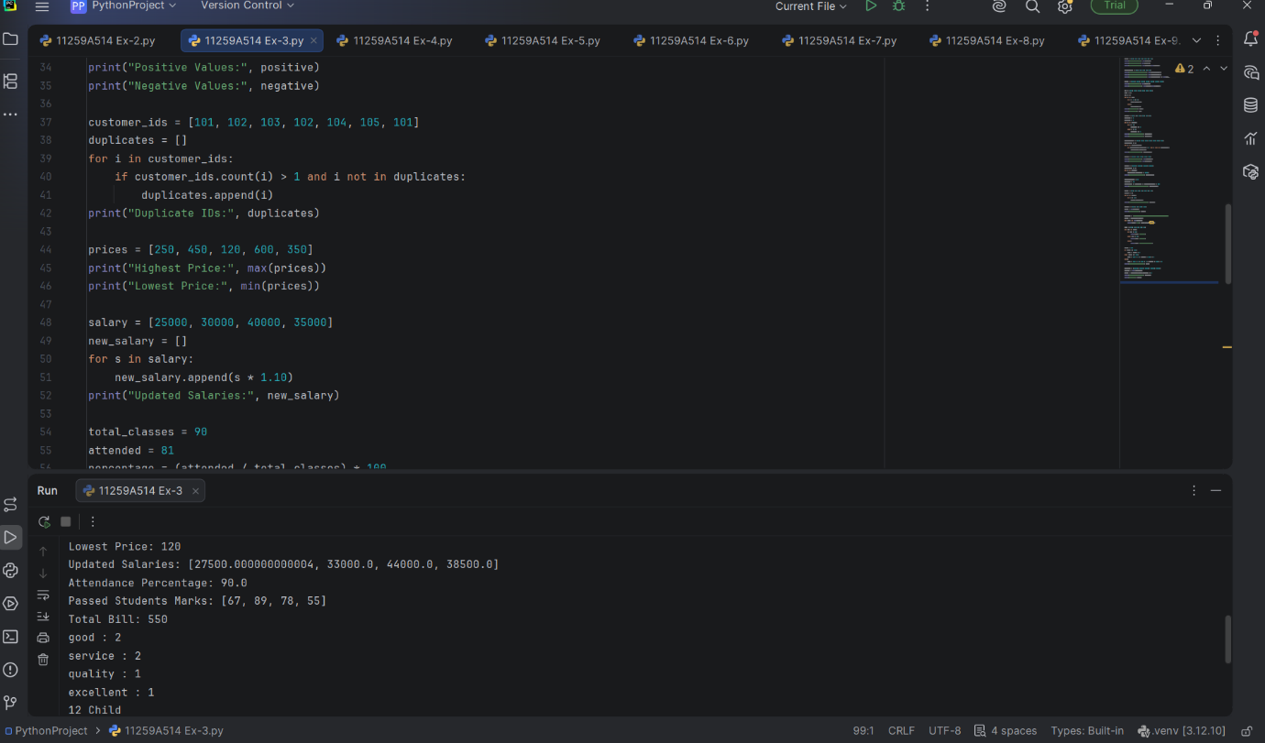

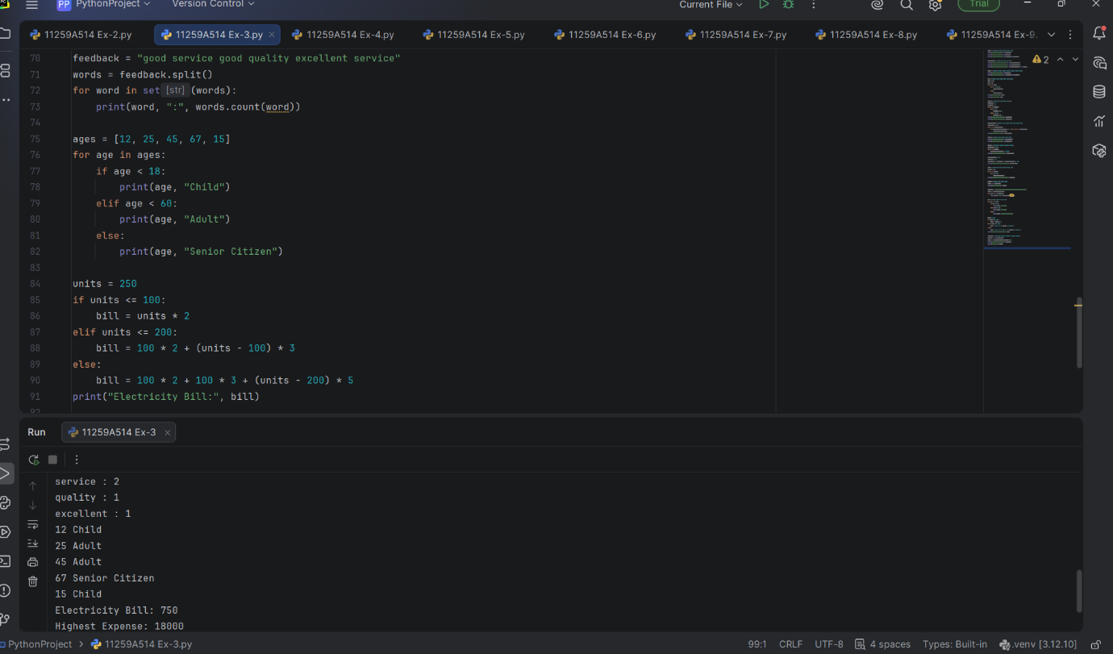

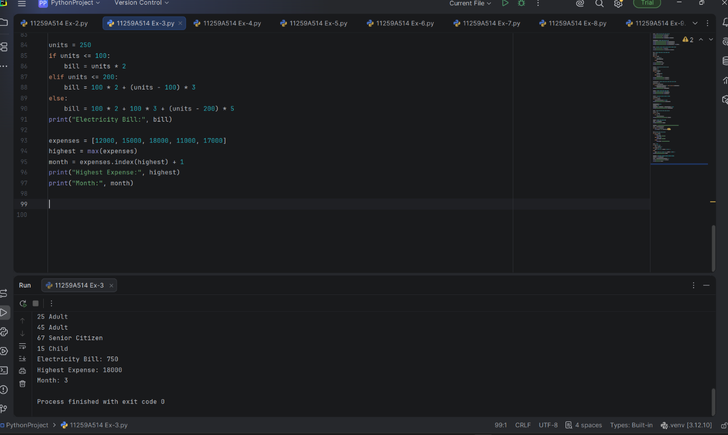

EXERCISE-4
# Import libraries
import pandas as pd
from sklearn.preprocessing import LabelEncoder, StandardScaler
# Load dataset
df = pd.read_csv("Iris.csv")
# Display first 5 records
print("First 5 Records:")
print(df.head())
# Display dataset information
print("\nDataset Information:")
df.info()
# Check for missing values
print("\nMissing Values:")
print(df.isnull().sum())
# Remove the Id column
if "Id" in df.columns:
df = df.drop("Id", axis=1)
# Encode the target column (Species)
encoder = LabelEncoder()
df["Species"] = encoder.fit_transform(df["Species"])
print("\nEncoded Species:")
print(df.head())
# Feature Scaling
scaler = StandardScaler()
features = [
"SepalLengthCm",
"SepalWidthCm",
"PetalLengthCm",
"PetalWidthCm"
]
df[features] = scaler.fit_transform (df[features])
# Display preprocessed dataset
print("\nPreprocessed Dataset:")
print(df.head())

OUTPUT

EXERCISE-5
# Dataset Splitting and Cross-Validation
# Using Iris Dataset
from sklearn.datasets import load_iris
from sklearn.model_selection import train_test_split, KFold, cross_val_score
from sklearn.linear_model import LogisticRegression
from sklearn.metrics import accuracy_score
# --------------------------------------------------
# Step 1: Load the Iris Dataset
# --------------------------------------------------
iris = load_iris()
X = iris.data
y = iris.target
print("Dataset Shape:", X.shape)
print("Number of Samples:", len(X))
print("Number of Features:", X.shape[1])
print("Target Classes:", iris.target_names)
# --------------------------------------------------
# Step 2: Split Dataset into Training and Testing
# --------------------------------------------------
X_train, X_test, y_train, y_test = train_test_split(
X,
y,
test_size=0.20,
random_state=42,
stratify=y
)
print("\nDataset Splitting")
print("-----------------")
print("Training samples:", len(X_train))
print("Testing samples :", len(X_test))
# --------------------------------------------------
# Step 3: Create Logistic Regression Model
# --------------------------------------------------
model = LogisticRegression(max_iter=200)
# Train the model
model.fit(X_train, y_train)
# --------------------------------------------------
# Step 4: Predict Test Data
# --------------------------------------------------
y_pred = model.predict(X_test)
# Calculate test accuracy
accuracy = accuracy_score(y_test, y_pred)
print("\nTest Set Performance")
print("--------------------")
print("Test Accuracy:", round(accuracy, 4))
# --------------------------------------------------
# Step 5: Implement 5-Fold Cross-Validation
# --------------------------------------------------
kf = KFold(
n_splits=5,
shuffle=True,
random_state=42
)
cv_scores = cross_val_score(
model,
X,
y,
cv=kf,
scoring='accuracy'
)
print("\n5-Fold Cross-Validation")
print("-----------------------")
for i, score in enumerate(cv_scores, start=1):
print("Fold", i, "Accuracy:", round(score, 4))
# --------------------------------------------------
# Step 6: Calculate Average Cross-Validation Score
# --------------------------------------------------
print("\nCross-Validation Results")
print("------------------------")
print("Average Accuracy:",
round(cv_scores.mean(), 4))
print("Standard Deviation:",
round(cv_scores.std(), 4))

OUTPUT
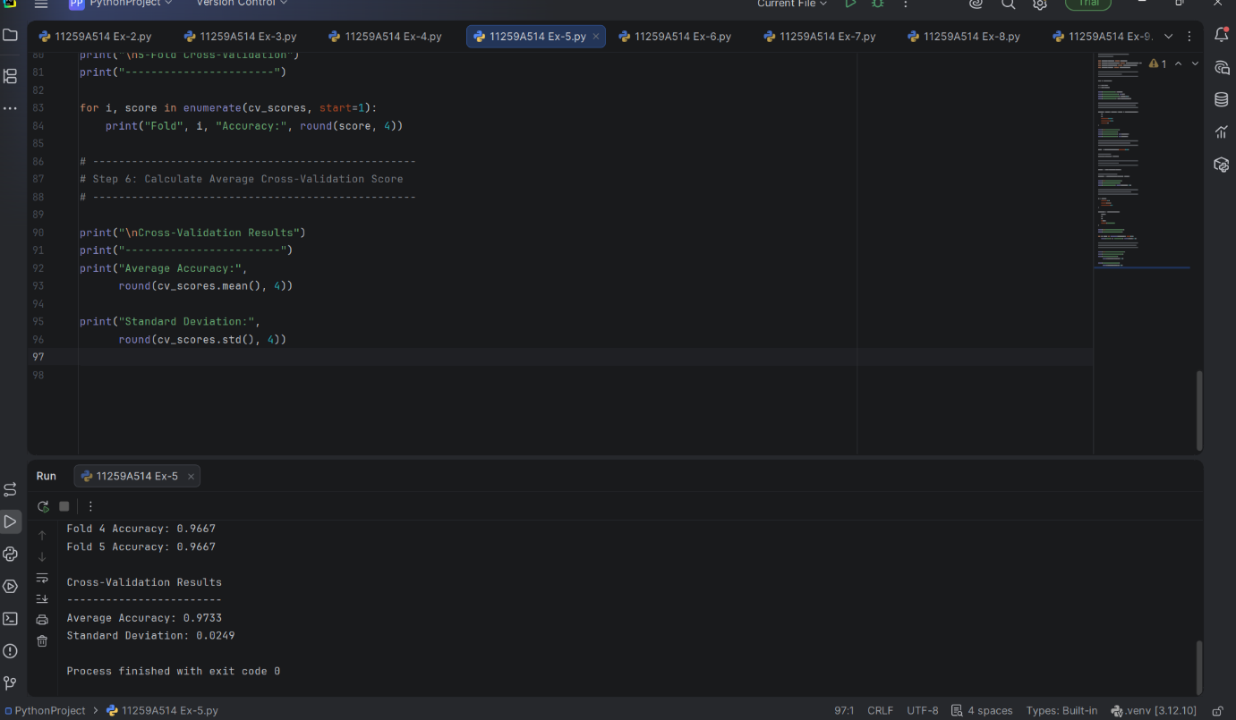

EXERCISE-6
# Linear Regression using Iris Dataset
from sklearn.datasets import load_iris
from sklearn.model_selection import train_test_split
from sklearn.linear_model import LinearRegression
from sklearn.metrics import mean_squared_error, mean_absolute_error, r2_score
import numpy as np
# -------------------------------------------------
# Step 1: Load Iris Dataset
# -------------------------------------------------
iris = load_iris()
X = iris.data
feature_names = iris.feature_names
# Predict Petal Length
# Column 2 = Petal Length
y = iris.data[:, 2]
# Use Sepal Length, Sepal Width and Petal Width
# as input features
X = iris.data[:, [0, 1, 3]]
print("Features:")
print(feature_names)
print("\nDataset Shape:", X.shape)
print("Target Shape:", y.shape)
# -------------------------------------------------
# Step 2: Split Dataset
# -------------------------------------------------
X_train, X_test, y_train, y_test = train_test_split(
X,
y,
test_size=0.20,
random_state=42
)
print("\nTraining Samples:", len(X_train))
print("Testing Samples :", len(X_test))
# -------------------------------------------------
# Step 3: Create Linear Regression Model
# -------------------------------------------------
model = LinearRegression()
# -------------------------------------------------
# Step 4: Train the Model
# -------------------------------------------------
model.fit(X_train, y_train)
# -------------------------------------------------
# Step 5: Make Predictions
# -------------------------------------------------
y_pred = model.predict(X_test)
# -------------------------------------------------
# Step 6: Display Predictions
# -------------------------------------------------
print("\nActual vs Predicted Values")
print("--------------------------------")
for actual, predicted in zip(y_test[:10], y_pred[:10]):
print("Actual:", round(actual, 2),
" Predicted:", round(predicted, 2))
# -------------------------------------------------
# Step 7: Evaluate the Model
# -------------------------------------------------
mse = mean_squared_error(y_test, y_pred)
rmse = np.sqrt(mse)
mae = mean_absolute_error(y_test, y_pred)
r2 = r2_score(y_test, y_pred)
print("\nModel Evaluation")
print("-----------------------------")
print("Mean Squared Error (MSE):", round(mse, 4))
print("Root Mean Squared Error (RMSE):", round(rmse, 4))
print("Mean Absolute Error (MAE):", round(mae, 4))
print("R2 Score:", round(r2, 4))
# -------------------------------------------------
# Step 8: Display Model Coefficients
# -------------------------------------------------
print("\nModel Coefficients")
print("-----------------------------")
for name, coefficient in zip(
["Sepal Length", "Sepal Width", "Petal Width"],
model.coef_):
print(name, ":", round(coefficient, 4))
print("Intercept:", round(model.intercept_, 4))
OUTPUT
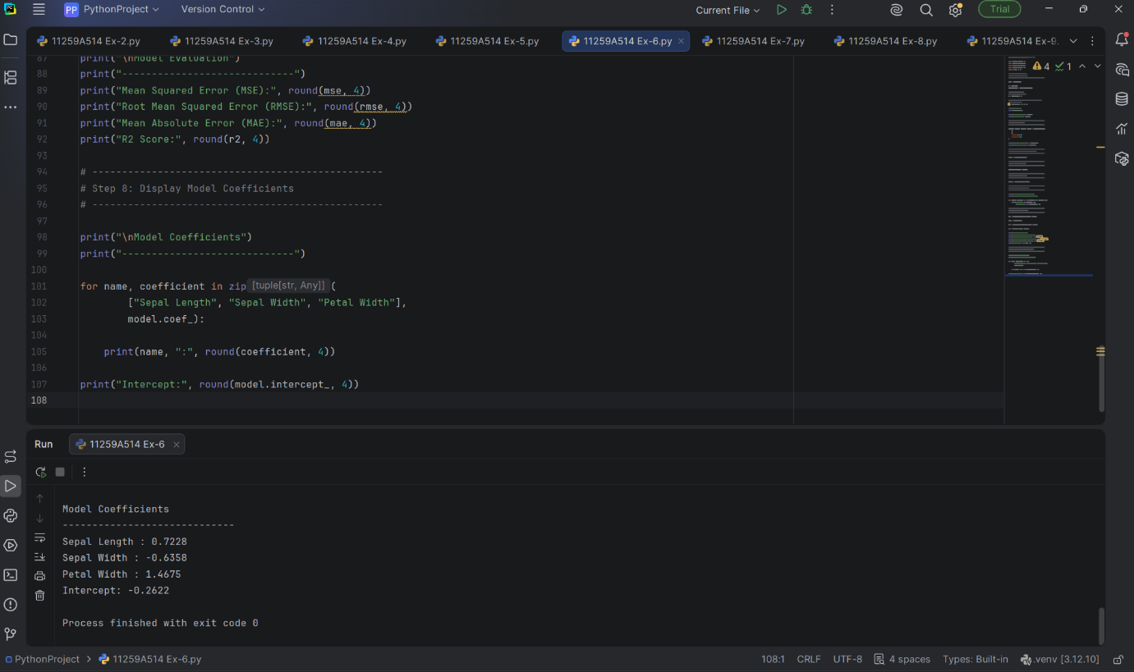

EXERCISE-7
# KNN Classification using Iris Dataset
from sklearn.datasets import load_iris
from sklearn.model_selection import train_test_split
from sklearn.preprocessing import StandardScaler
from sklearn.neighbors import KNeighborsClassifier
from sklearn.metrics import (
accuracy_score,
confusion_matrix,
precision_score,
recall_score,
f1_score
)
# --------------------------------------------------
# Step 1: Load Iris Dataset
# --------------------------------------------------
iris = load_iris()
X = iris.data
y = iris.target
print("Dataset Shape:", X.shape)
print("Number of Samples:", len(X))
print("Number of Features:", X.shape[1])
print("Target Classes:", iris.target_names)
# --------------------------------------------------
# Step 2: Split Dataset
# --------------------------------------------------
X_train, X_test, y_train, y_test = train_test_split(
X,
y,
test_size=0.20,
random_state=42,
stratify=y
)
print("\nDataset Splitting")
print("-----------------")
print("Training samples:", len(X_train))
print("Testing samples :", len(X_test))
# --------------------------------------------------
# Step 3: Feature Scaling
# --------------------------------------------------
scaler = StandardScaler()
X_train = scaler.fit_transform(X_train)
X_test = scaler.transform(X_test)
# --------------------------------------------------
# Step 4: Create KNN Model
# --------------------------------------------------
knn = KNeighborsClassifier(n_neighbors=5)
# --------------------------------------------------
# Step 5: Train the Model
# --------------------------------------------------
knn.fit(X_train, y_train)
# --------------------------------------------------
# Step 6: Make Predictions
# --------------------------------------------------
y_pred = knn.predict(X_test)
# --------------------------------------------------
# Step 7: Calculate Evaluation Metrics
# --------------------------------------------------
accuracy = accuracy_score(y_test, y_pred)
cm = confusion_matrix(y_test, y_pred)
precision = precision_score(
y_test,
y_pred,
average='weighted'
)
recall = recall_score(
y_test,
y_pred,
average='weighted'
)
f1 = f1_score(
y_test,
y_pred,
average='weighted'
)
# --------------------------------------------------
# Step 8: Display Results
# --------------------------------------------------
print("\nKNN Model Evaluation")
print("--------------------")
print("Accuracy :", round(accuracy, 4))
print("Precision:", round(precision, 4))
print("Recall :", round(recall, 4))
print("F1-Score :", round(f1, 4))
print("\nConfusion Matrix")
print("----------------")
print(cm)
OUTPUT
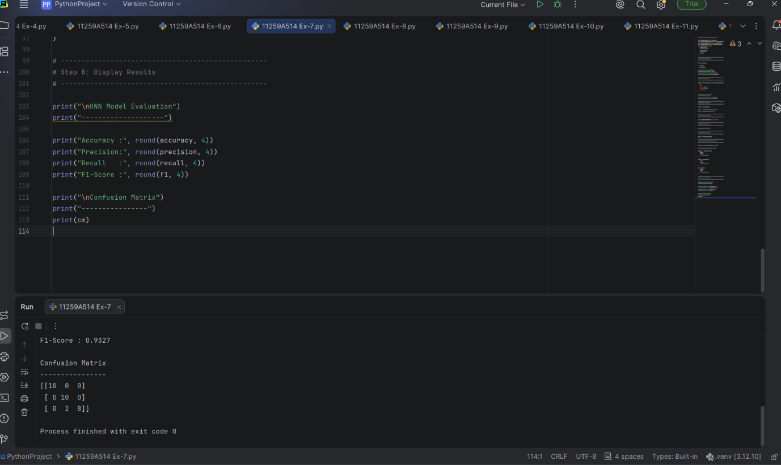

EXERCISE-8
# SVM Classification using Iris Dataset
from sklearn.datasets import load_iris
from sklearn.model_selection import train_test_split
from sklearn.preprocessing import StandardScaler
from sklearn.svm import SVC
from sklearn.metrics import (
accuracy_score,
confusion_matrix,
precision_score,
recall_score,
f1_score
)
# --------------------------------------------------
# Step 1: Load Iris Dataset
# --------------------------------------------------
iris = load_iris()
X = iris.data
y = iris.target
print("Dataset Shape:", X.shape)
print("Number of Samples:", len(X))
print("Number of Features:", X.shape[1])
print("Target Classes:", iris.target_names)
# --------------------------------------------------
# Step 2: Split Dataset
# --------------------------------------------------
X_train, X_test, y_train, y_test = train_test_split(
X,
y,
test_size=0.20,
random_state=42,
stratify=y
)
print("\nDataset Splitting")
print("-----------------")
print("Training samples:", len(X_train))
print("Testing samples :", len(X_test))
# --------------------------------------------------
# Step 3: Feature Scaling
# --------------------------------------------------
scaler = StandardScaler()
X_train = scaler.fit_transform(X_train)
X_test = scaler.transform(X_test)
# --------------------------------------------------
# Step 4: Create SVM Model
# --------------------------------------------------
model = SVC(
kernel='linear',
C=1.0
)
# --------------------------------------------------
# Step 5: Train the Model
# --------------------------------------------------
model.fit(X_train, y_train)
# --------------------------------------------------
# Step 6: Make Predictions
# --------------------------------------------------
y_pred = model.predict(X_test)
# --------------------------------------------------
# Step 7: Calculate Evaluation Metrics
# --------------------------------------------------
accuracy = accuracy_score(y_test, y_pred)
cm = confusion_matrix(y_test, y_pred)
precision = precision_score(
y_test,
y_pred,
average='weighted'
)
recall = recall_score(
y_test,
y_pred,
average='weighted'
)
f1 = f1_score(
y_test,
y_pred,
average='weighted'
)
# --------------------------------------------------
# Step 8: Display Results
# --------------------------------------------------
print("\nSVM Model Evaluation")
print("--------------------")
print("Accuracy :", round(accuracy, 4))
print("Precision:", round(precision, 4))
print("Recall :", round(recall, 4))
print("F1-Score :", round(f1, 4))
print("\nConfusion Matrix")
print("----------------")
print(cm)
OUTPUT
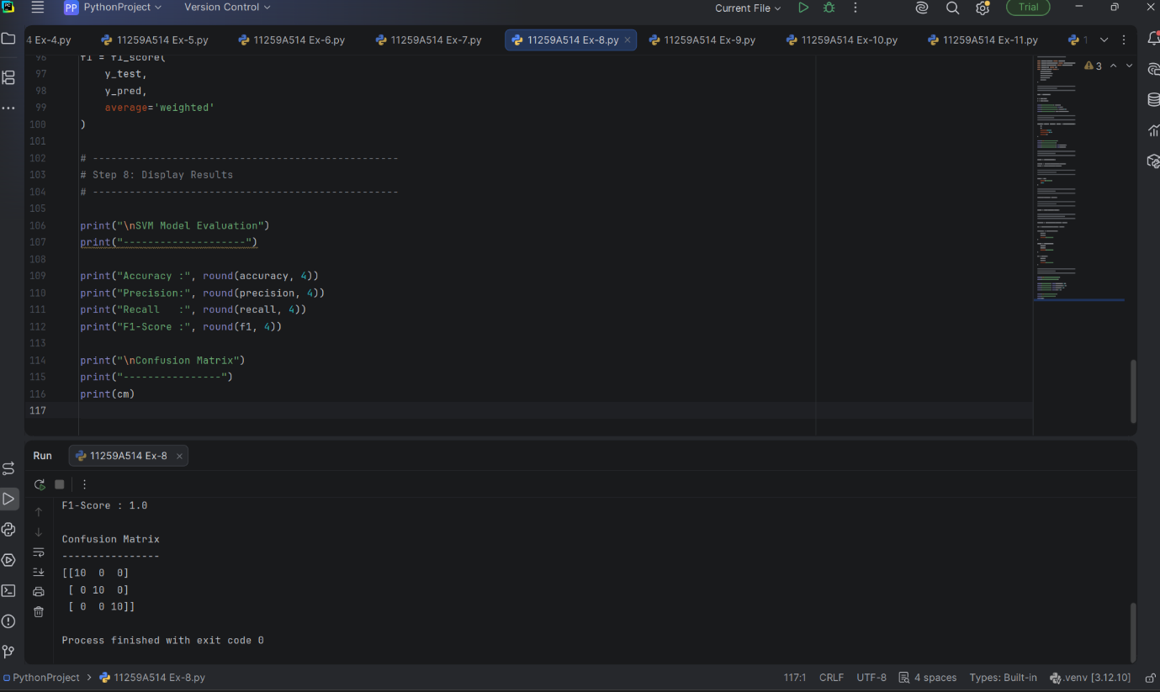

EXERCISE-9
# K-Means Clustering using Iris Dataset
from sklearn.datasets import load_iris
from sklearn.cluster import KMeans
from sklearn.preprocessing import StandardScaler
from sklearn.metrics import silhouette_score
import matplotlib.pyplot as plt
# --------------------------------------------------
# Step 1: Load Iris Dataset
# --------------------------------------------------
iris = load_iris()
X = iris.data
y = iris.target
print("Dataset Shape:", X.shape)
print("Number of Samples:", X.shape[0])
print("Number of Features:", X.shape[1])
print("\nFeatures:")
print(iris.feature_names)
# --------------------------------------------------
# Step 2: Feature Scaling
# --------------------------------------------------
scaler = StandardScaler()
X_scaled = scaler.fit_transform(X)
# --------------------------------------------------
# Step 3: Create K-Means Model
# --------------------------------------------------
kmeans = KMeans(
n_clusters=3,
random_state=42,
n_init=10
)
# --------------------------------------------------
# Step 4: Fit K-Means Model
# --------------------------------------------------
kmeans.fit(X_scaled)
# --------------------------------------------------
# Step 5: Get Cluster Labels
# --------------------------------------------------
labels = kmeans.labels_
# --------------------------------------------------
# Step 6: Get Cluster Centroids
# --------------------------------------------------
centroids = kmeans.cluster_centers_
# --------------------------------------------------
# Step 7: Display Results
# --------------------------------------------------
print("\nCluster Labels:")
print(labels)
print("\nCluster Centroids:")
print(centroids)
# --------------------------------------------------
# Step 8: Calculate Silhouette Score
# --------------------------------------------------
silhouette = silhouette_score(X_scaled, labels)
print("\nCluster Evaluation")
print("------------------")
print("Silhouette Score:",
round(silhouette, 4))
# --------------------------------------------------
# Step 9: Display Cluster Count
# --------------------------------------------------
print("\nNumber of Samples in Each Cluster:")
for i in range(3):
print(
"Cluster", i,
":",
sum(labels == i),
"samples"
)
# --------------------------------------------------
# Step 10: Visualize Clusters
# --------------------------------------------------
plt.figure(figsize=(8, 6))
plt.scatter(
X_scaled[:, 2],
X_scaled[:, 3],
c=labels
)
plt.scatter(
centroids[:, 2],
centroids[:, 3],
marker='X',
s=200
)
plt.xlabel("Petal Length")
plt.ylabel("Petal Width")
plt.title("K-Means Clustering on Iris Dataset")
plt.show()
OUTPUT
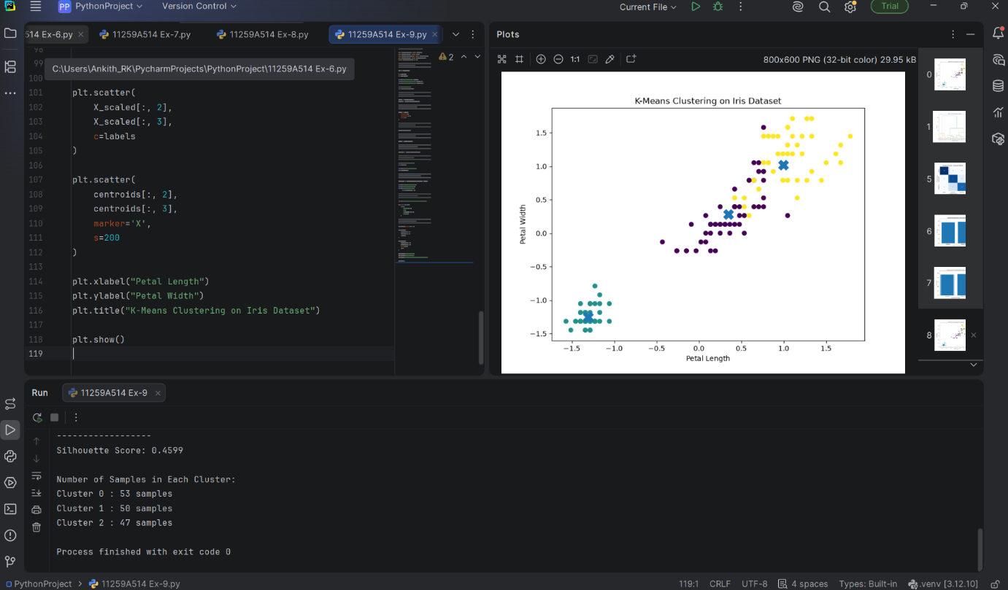
EXERCISE-10
# Hierarchical Clustering using Iris Dataset
import matplotlib.pyplot as plt
from sklearn.datasets import load_iris
from sklearn.preprocessing import StandardScaler
from sklearn.cluster import AgglomerativeClustering
from sklearn.metrics import silhouette_score
from scipy.cluster.hierarchy import dendrogram, linkage
# --------------------------------------------------
# Step 1: Load Iris Dataset
# --------------------------------------------------
iris = load_iris()
X = iris.data
y = iris.target
print("Dataset Shape:", X.shape)
print("Number of Samples:", X.shape[0])
print("Number of Features:", X.shape[1])
print("\nFeatures:")
print(iris.feature_names)
# --------------------------------------------------
# Step 2: Feature Scaling
# --------------------------------------------------
scaler = StandardScaler()
X_scaled = scaler.fit_transform(X)
# --------------------------------------------------
# Step 3: Create Dendrogram
# --------------------------------------------------
linked = linkage(X_scaled, method='ward')
plt.figure(figsize=(10, 6))
dendrogram(
linked,
truncate_mode='lastp',
p=20
)
plt.title("Hierarchical Clustering Dendrogram")
plt.xlabel("Data Points / Clusters")
plt.ylabel("Distance")
plt.show()
# --------------------------------------------------
# Step 4: Apply Agglomerative Clustering
# --------------------------------------------------
model = AgglomerativeClustering(
n_clusters=3,
linkage='ward'
)
labels = model.fit_predict(X_scaled)
# --------------------------------------------------
# Step 5: Display Cluster Labels
# --------------------------------------------------
print("\nCluster Labels:")
print(labels)
# --------------------------------------------------
# Step 6: Calculate Silhouette Score
# --------------------------------------------------
silhouette = silhouette_score(
X_scaled,
labels
)
print("\nSilhouette Score:",
round(silhouette, 4))
# --------------------------------------------------
# Step 7: Count Samples in Each Cluster
# --------------------------------------------------
print("\nNumber of Samples in Each Cluster:")
for i in range(3):
print(
"Cluster", i,
":",
sum(labels == i),
"samples"
)
# --------------------------------------------------
# Step 8: Visualize Clusters
# --------------------------------------------------
plt.figure(figsize=(8, 6))
plt.scatter(
X_scaled[:, 2],
X_scaled[:, 3],
c=labels
)
plt.xlabel("Petal Length")
plt.ylabel("Petal Width")
plt.title("Hierarchical Clustering on Iris Dataset")
plt.show()
OUTPUT
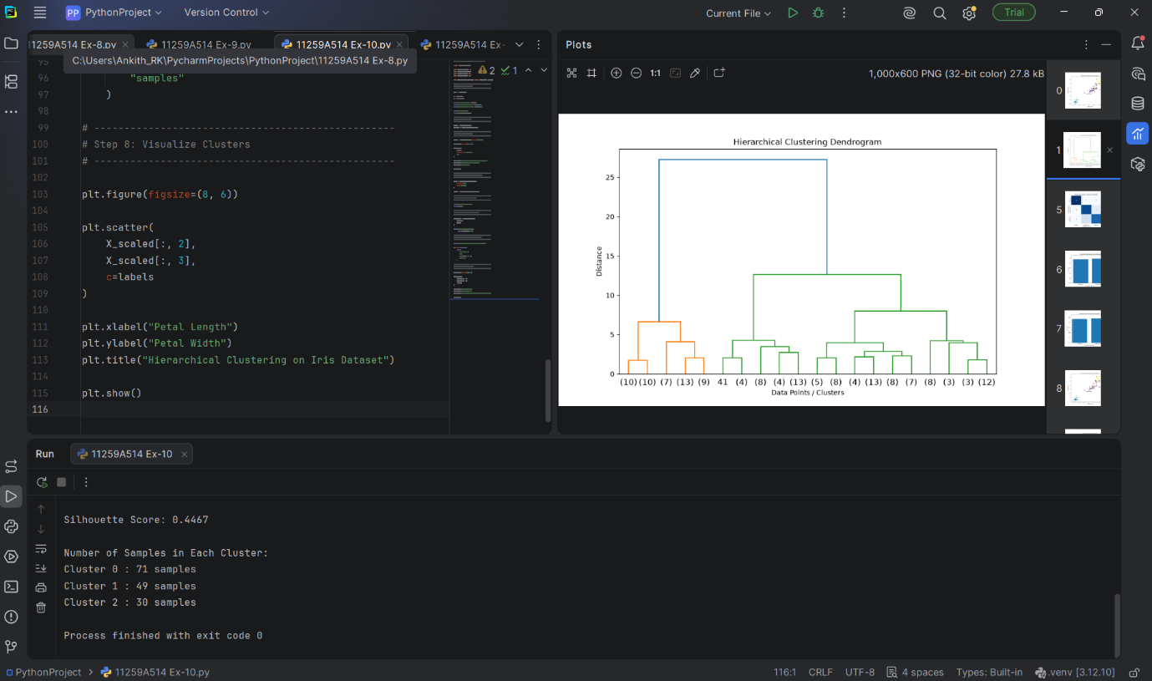

EXERCISE-11
# Random Forest Classification using Iris Dataset
from sklearn.datasets import load_iris
from sklearn.model_selection import train_test_split
from sklearn.ensemble import RandomForestClassifier
from sklearn.metrics import (
accuracy_score,
confusion_matrix,
classification_report
)
import matplotlib.pyplot as plt
import seaborn as sns
# 1. Load Iris dataset
iris = load_iris()
X = iris.data
y = iris.target
# 2. Split dataset into training and testing sets
X_train, X_test, y_train, y_test = train_test_split(
X, y,
test_size=0.20,
random_state=42,
stratify=y
)
# 3. Create Random Forest model
model = RandomForestClassifier(
n_estimators=100,
random_state=42
)
# 4. Train the model
model.fit(X_train, y_train)
# 5. Make predictions
y_pred = model.predict(X_test)
# 6. Calculate accuracy
accuracy = accuracy_score(y_test, y_pred)
print("Random Forest Classification")
print("----------------------------")
print("Number of trees:", 100)
print("Accuracy:", accuracy)
# 7. Confusion Matrix
cm = confusion_matrix(y_test, y_pred)
print("\nConfusion Matrix:")
print(cm)
# 8. Classification Report
print("\nClassification Report:")
print(classification_report(
y_test,
y_pred,
target_names=iris.target_names
))
# 9. Display Confusion Matrix
plt.figure(figsize=(6, 4))
sns.heatmap(
cm,
annot=True,
fmt="d",
cmap="Blues",
xticklabels=iris.target_names,
yticklabels=iris.target_names
)
plt.xlabel("Predicted Class")
plt.ylabel("Actual Class")
plt.title("Random Forest - Confusion Matrix")
plt.show()

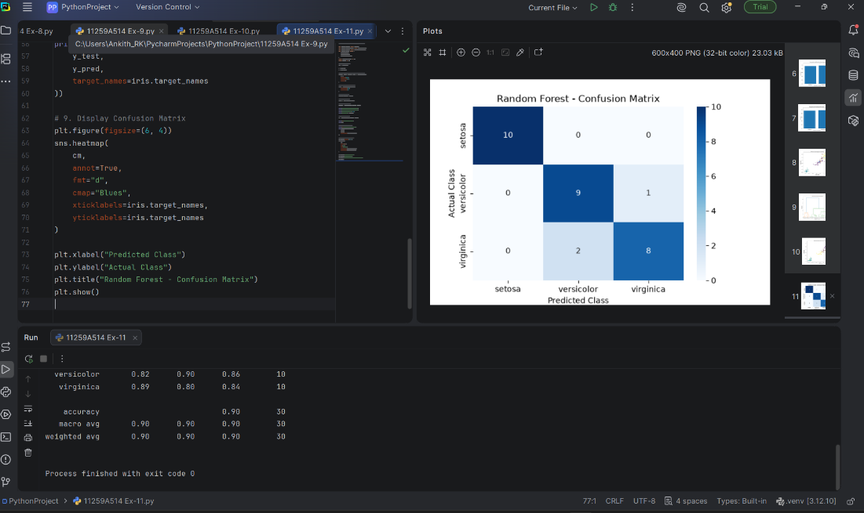
EXERCISE-12
# Implement Boosting Techniques and Compare Results
# Dataset: Iris
from sklearn.datasets import load_iris
from sklearn.model_selection import train_test_split
from sklearn.ensemble import AdaBoostClassifier, GradientBoostingClassifier
from sklearn.metrics import accuracy_score, precision_score, recall_score, f1_score
import matplotlib.pyplot as plt
# 1. Load dataset
iris = load_iris()
X = iris.data
y = iris.target
# 2. Split dataset
X_train, X_test, y_train, y_test = train_test_split(
X, y,
test_size=0.20,
random_state=42,
stratify=y
)
# 3. Create AdaBoost model
ada_model = AdaBoostClassifier(
n_estimators=100,
random_state=42
)
# 4. Create Gradient Boosting model
gb_model = GradientBoostingClassifier(
n_estimators=100,
random_state=42
)
# 5. Train models
ada_model.fit(X_train, y_train)
gb_model.fit(X_train, y_train)
# 6. Predictions
ada_pred = ada_model.predict(X_test)
gb_pred = gb_model.predict(X_test)
# 7. Function to calculate performance
def evaluate_model(name, y_test, y_pred):
accuracy = accuracy_score(y_test, y_pred)
precision = precision_score(
y_test, y_pred, average="weighted"
)
recall = recall_score(
y_test, y_pred, average="weighted"
)
f1 = f1_score(
y_test, y_pred, average="weighted"
)
print("\n", name)
print("-" * 30)
print("Accuracy :", round(accuracy, 4))
print("Precision:", round(precision, 4))
print("Recall :", round(recall, 4))
print("F1-Score :", round(f1, 4))
return accuracy, precision, recall, f1
# 8. Evaluate AdaBoost
ada_results = evaluate_model(
"AdaBoost",
y_test,
ada_pred
)
# 9. Evaluate Gradient Boosting
gb_results = evaluate_model(
"Gradient Boosting",
y_test,
gb_pred
)
# 10. Compare accuracy
models = ["AdaBoost", "Gradient Boosting"]
accuracies = [
ada_results[0],
gb_results[0]
]
plt.figure(figsize=(7, 5))
plt.bar(models, accuracies)
plt.xlabel("Boosting Technique")
plt.ylabel("Accuracy")
plt.title("Comparison of Boosting Techniques")
plt.ylim(0, 1.1)
plt.show()
OUTPUT
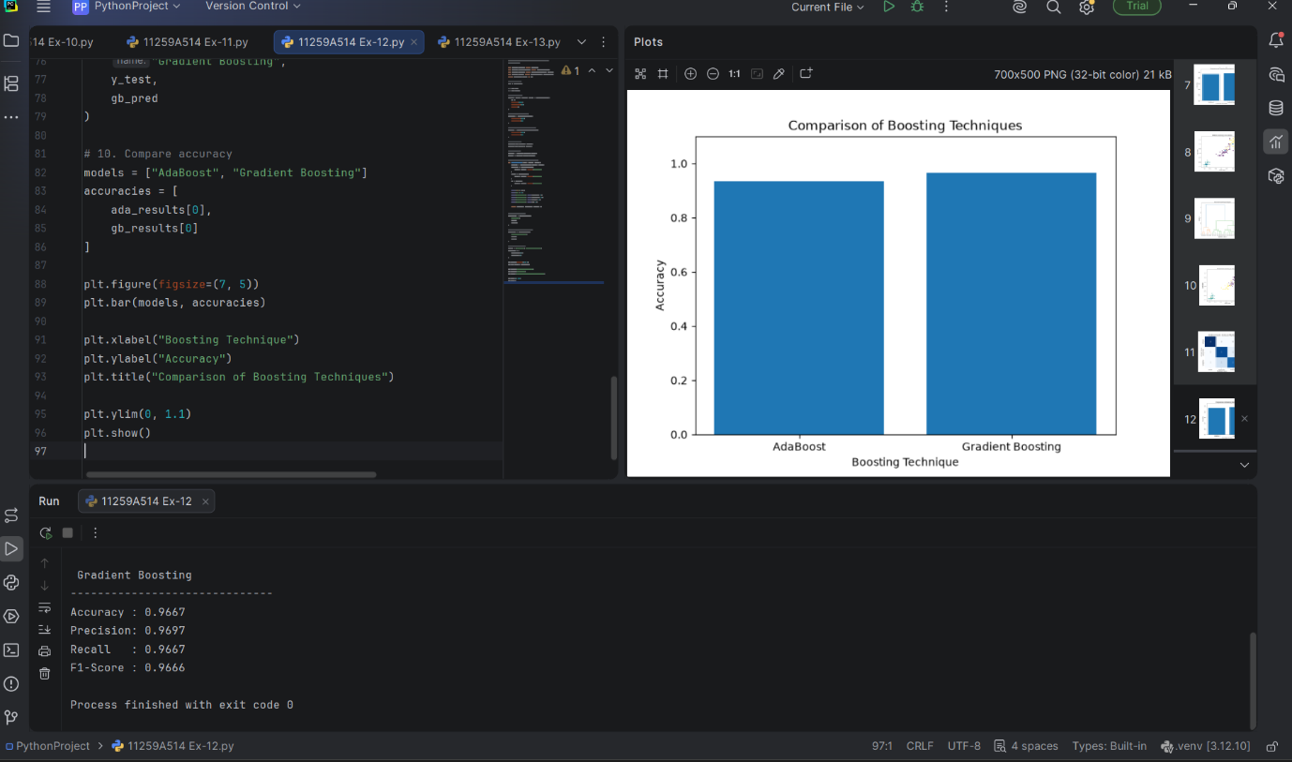

EXERCISE-13
import numpy as np
import random
# Number of states and actions
num_states = 5
num_actions = 2
# Actions
# 0 = Left
# 1 = Right
# Initialize Q-table
Q = np.zeros((num_states, num_actions))
# Parameters
alpha = 0.1 # Learning rate
gamma = 0.9 # Discount factor
epsilon = 0.2 # Exploration probability
episodes = 1000
# Environment function
def get_next_state(state, action):
if action == 0: # Move Left
next_state = max(0, state - 1)
else: # Move Right
next_state = min(num_states - 1, state + 1)
# Reward
if next_state == 4:
reward = 10
else:
reward = -1
return next_state, reward
# Q-Learning
for episode in range(episodes):
state = 0
while state != 4:
# Epsilon-greedy action selection
if random.random() < epsilon:
action = random.randint(0, 1)
else:
action = np.argmax(Q[state])
# Perform action
next_state, reward = get_next_state(state, action)
# Q-learning update
Q[state, action] = Q[state, action] + alpha * (
reward +
gamma * np.max(Q[next_state]) -
Q[state, action]
)
state = next_state
# Display Q-table
print("Learned Q-Table:")
print(Q)
# Test the learned policy
state = 0
path = [state]
while state != 4:
action = np.argmax(Q[state])
next_state, reward = get_next_state(state, action)
state = next_state
path.append(state)
print("\nLearned Path:")
print(path)
print("\nOptimal Policy:")
for state in range(num_states - 1):
action = np.argmax(Q[state])
if action == 0:
print("State", state, "-> Left")
else:
print("State", state, "-> Right")
OUTPUT
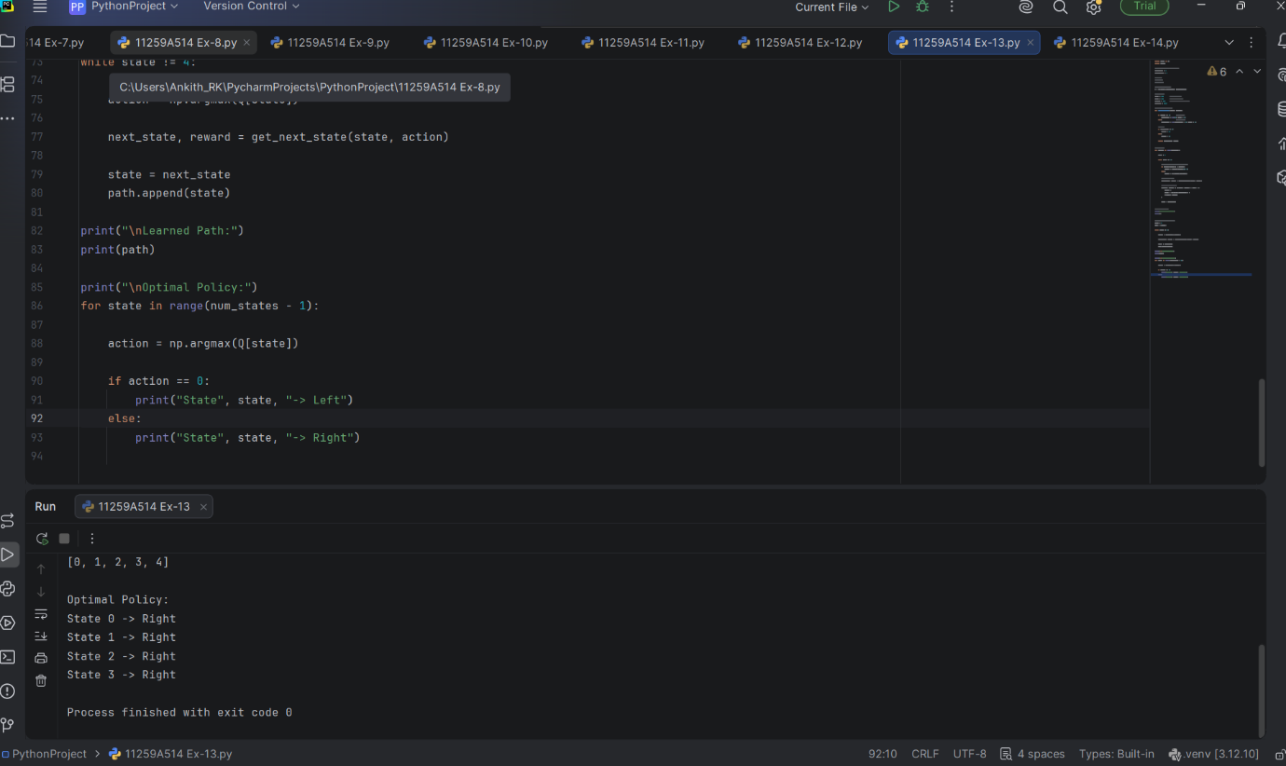
EXERCISE-14
# Build a Neural Network using TensorFlow/Keras
# Dataset: Iris
import numpy as np
import tensorflow as tf
from tensorflow.keras.models import Sequential
from tensorflow.keras.layers import Dense
from sklearn.datasets import load_iris
from sklearn.model_selection import train_test_split
from sklearn.preprocessing import StandardScaler
from sklearn.metrics import accuracy_score, classification_report
# 1. Load Iris dataset
iris = load_iris()
X = iris.data
y = iris.target
# 2. Split dataset
X_train, X_test, y_train, y_test = train_test_split(
X, y,
test_size=0.20,
random_state=42,
stratify=y
)
# 3. Standardize features
scaler = StandardScaler()
X_train = scaler.fit_transform(X_train)
X_test = scaler.transform(X_test)
# 4. Build neural network
model = Sequential([
Dense(16, activation='relu', input_shape=(4,)),
Dense(8, activation='relu'),
Dense(3, activation='softmax')
])
# 5. Compile model
model.compile(
optimizer='adam',
loss='sparse_categorical_crossentropy',
metrics=['accuracy']
)
# 6. Display model architecture
model.summary()
# 7. Train the model
history = model.fit(
X_train,
y_train,
epochs=50,
batch_size=8,
validation_split=0.2,
verbose=1
)
# 8. Evaluate model
loss, accuracy = model.evaluate(X_test, y_test, verbose=0)
print("\nTest Loss:", round(loss, 4))
print("Test Accuracy:", round(accuracy, 4))
# 9. Make predictions
y_probability = model.predict(X_test, verbose=0)
y_pred = np.argmax(y_probability, axis=1)
# 10. Classification report
print("\nClassification Report:")
print(classification_report(
y_test,
y_pred,
target_names=iris.target_names
))
OUTPUT


